**PRACTICAL – 8**

**AIM:**

**Add Two 32-bit numbers stored in consecutive memory locations and store the result in memory locations starting from 7000H**

**CODE:**

ORG 100H

MOV [7000H], 7615H

MOV [7002H], 1495H

MOV [7004H], 1515H

MOV [7006H], 1313H

MOV AX, [7000H]

MOV BX, [7002H]

MOV CX, [7004H]

MOV DX, [7006H]

ADD AX,CX

ADD BX,DX

MOV [7008H], AX

MOV [7010H], BX

RET

**OUTPUT:**

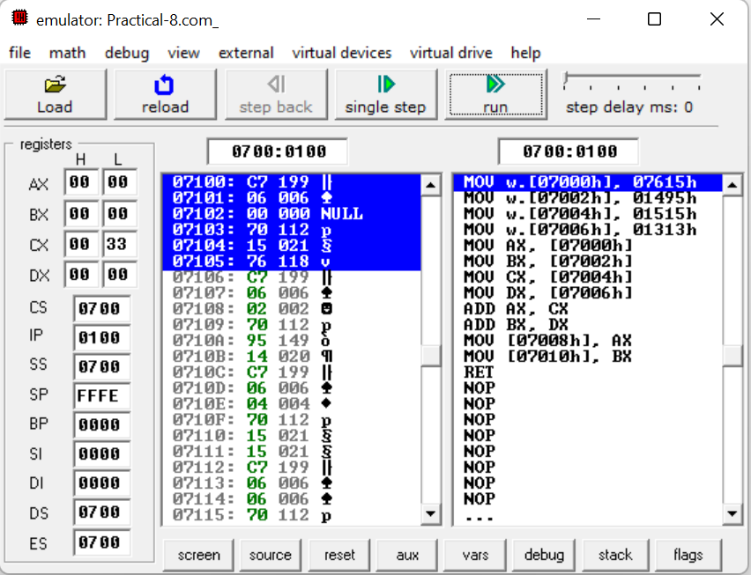

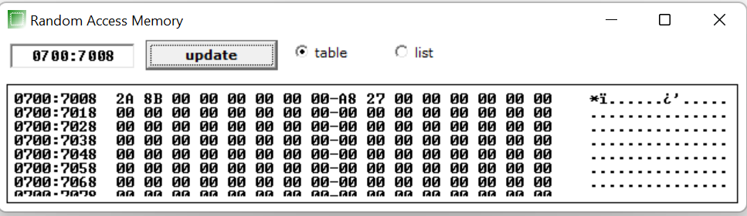

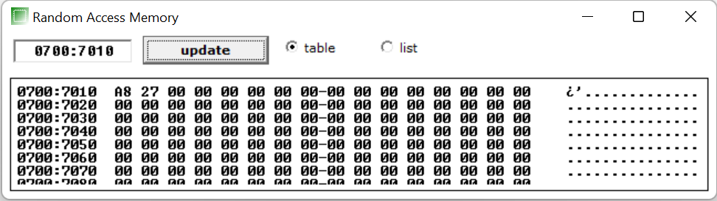

**CONCLUSION:** In this practical we learnt how to add two 32 bit number in consecutive memory location.